Change of Dates Notice
Local Sustainable Snack Program
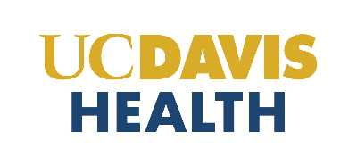
Request for Proposal # 04-18-24-DJ

The timeline of dates for this RFP have been changed. Please see the update below.

